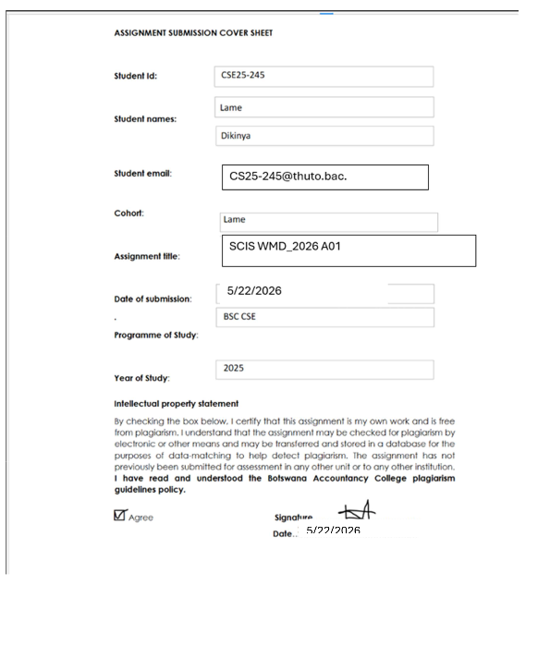
CSE25-245

1. Website Specifications
i. Purpose of the Website
The purpose of this website is to provide an online platform that allows clients to interact effectively with the fitness training company’s services. The website will enable users to explore training programs, select personal trainers, book sessions, manage appointments, and provide feedback.
Goals
- Provide 24/7 access to fitness services and information
- Showcase training programs, fitness styles, and trainer expertise
- Display workout plans, transformations, and success stories
- Enhance online presence, making it easier for potential clients to discover the business
- Strengthen the brand image and credibility
- Collect client feedback and reviews for continuous improvement

ii. Target Audience
- Teenagers and adults aged 15 to 40
- Students and working individuals
- Fitness beginners and experienced gym-goers
- Health-conscious and goal-oriented individuals
- Budget-conscious clients looking for affordable training options

iii. Technical Aptitude
Users of the website are expected to:
- Be comfortable using mobile devices and computers
- Be able to create accounts and log in
- Complete online forms for bookings and registrations
- Navigate both mobile and desktop interfaces easily
- Select trainers, programs, and schedules
- Leave reviews, ratings, and feedback
- Browse fitness galleries and transformation results

iv. Type of Website Content
- Fitness program descriptions and pricing
- Trainer profiles and specializations
- Online booking system for training sessions
- Appointment viewing, rescheduling, and cancellation
- Contact details and location information
- Fitness gallery (before/after transformations, workouts)
- Company information and branding
- Login and sign-up system

2. Information Design & Taxonomy
Site Map
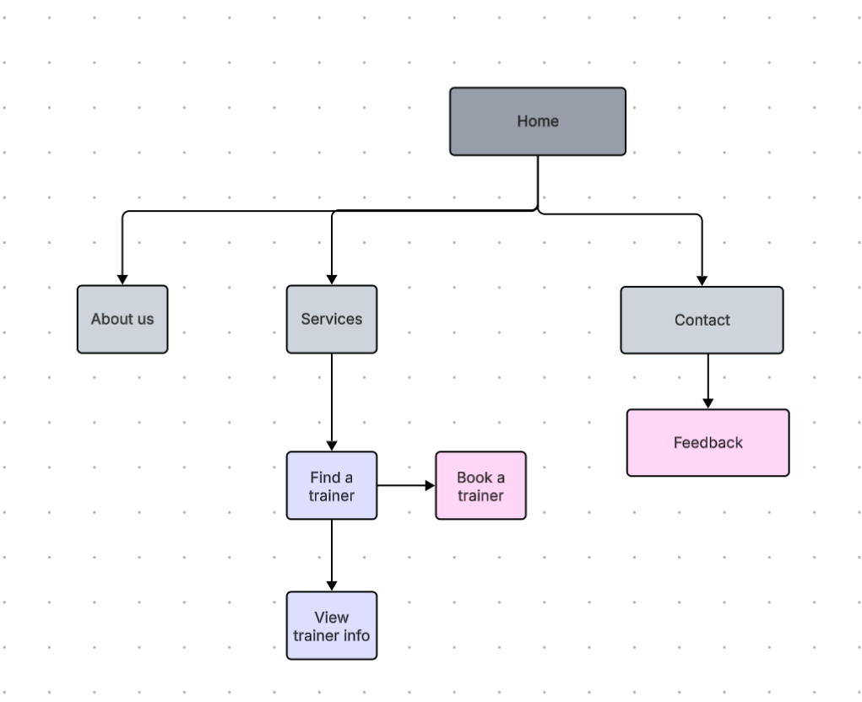
3. Page Template Design
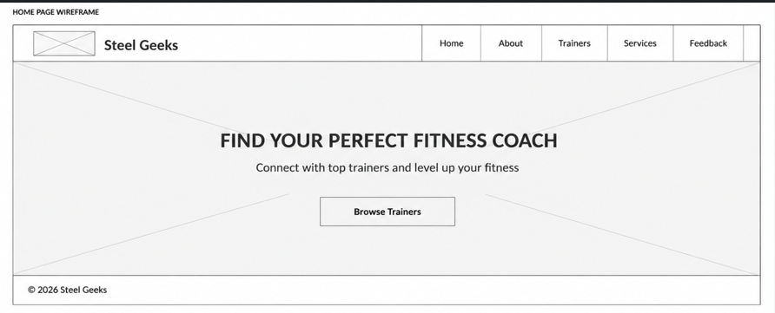
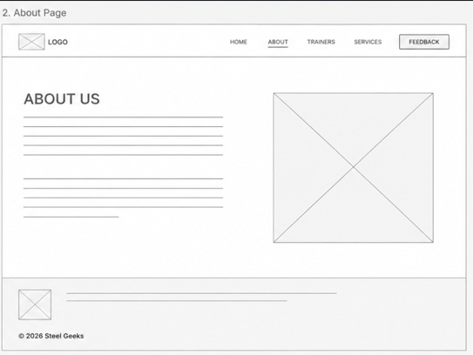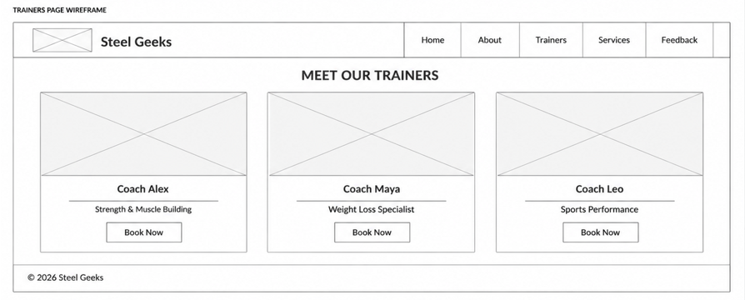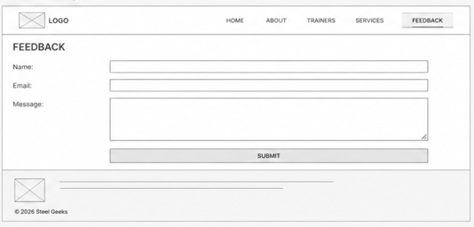
4. Technical Brief
The Fitness Geeks website will be developed using modern web technologies and software tools that are suitable for creating a responsive, attractive, and user-friendly fitness website.
Technologies to be Used
HTML5
HTML5 will be used to create the structure of the website pages such as the homepage, trainers page, classes page, and contact page.
CSS
CSS will be used to style the website by adding colors, layouts, fonts, spacing, animations, and responsive design features.
Bootstrap
Bootstrap will be used to simplify responsive web design and create professional-looking components such as navigation bars, cards, buttons, and grids.
JavaScript
JavaScript will be used to add interactivity to the website, such as image sliders, form validation, navigation effects, and dynamic content.

Software and Development Tools
Visual Studio Code (VS Code)
VS Code will be used as the main code editor for writing and managing HTML, CSS, JavaScript, and Bootstrap files.
Google Chrome
Chrome browser developer tools will be used for testing, debugging, and checking website responsiveness.
GitHub
GitHub may be used for storing and backing up the website project files and managing versions of the project.
Graphics and Design Tools
Canva
Canva will be used to design banners, promotional graphics, and fitness-themed visuals for the website.
Adobe Photoshop
These tools may be used to edit and optimize images before uploading them to the website.

5. Quality Assurance
Browser Compatibility test
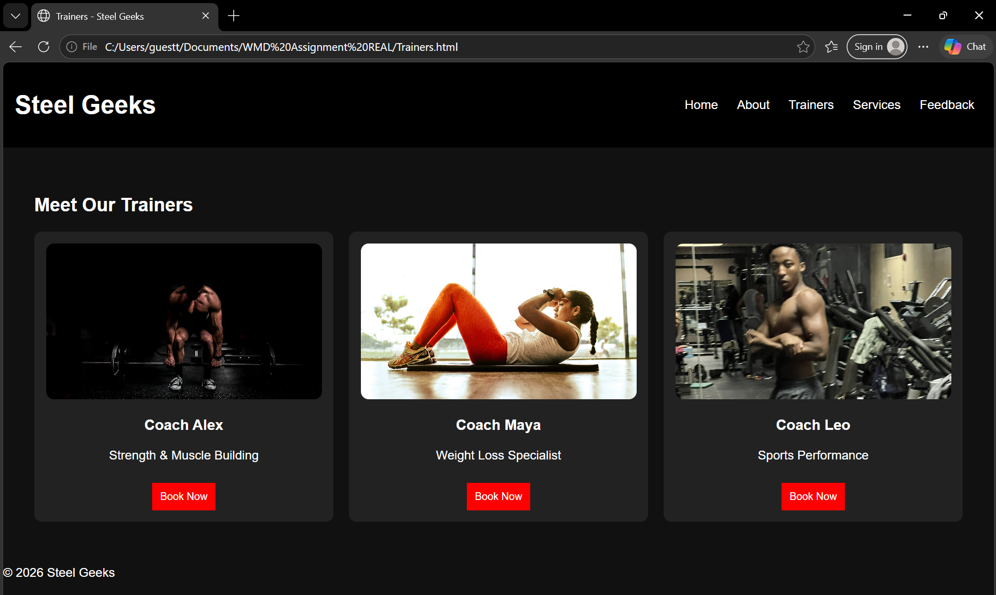
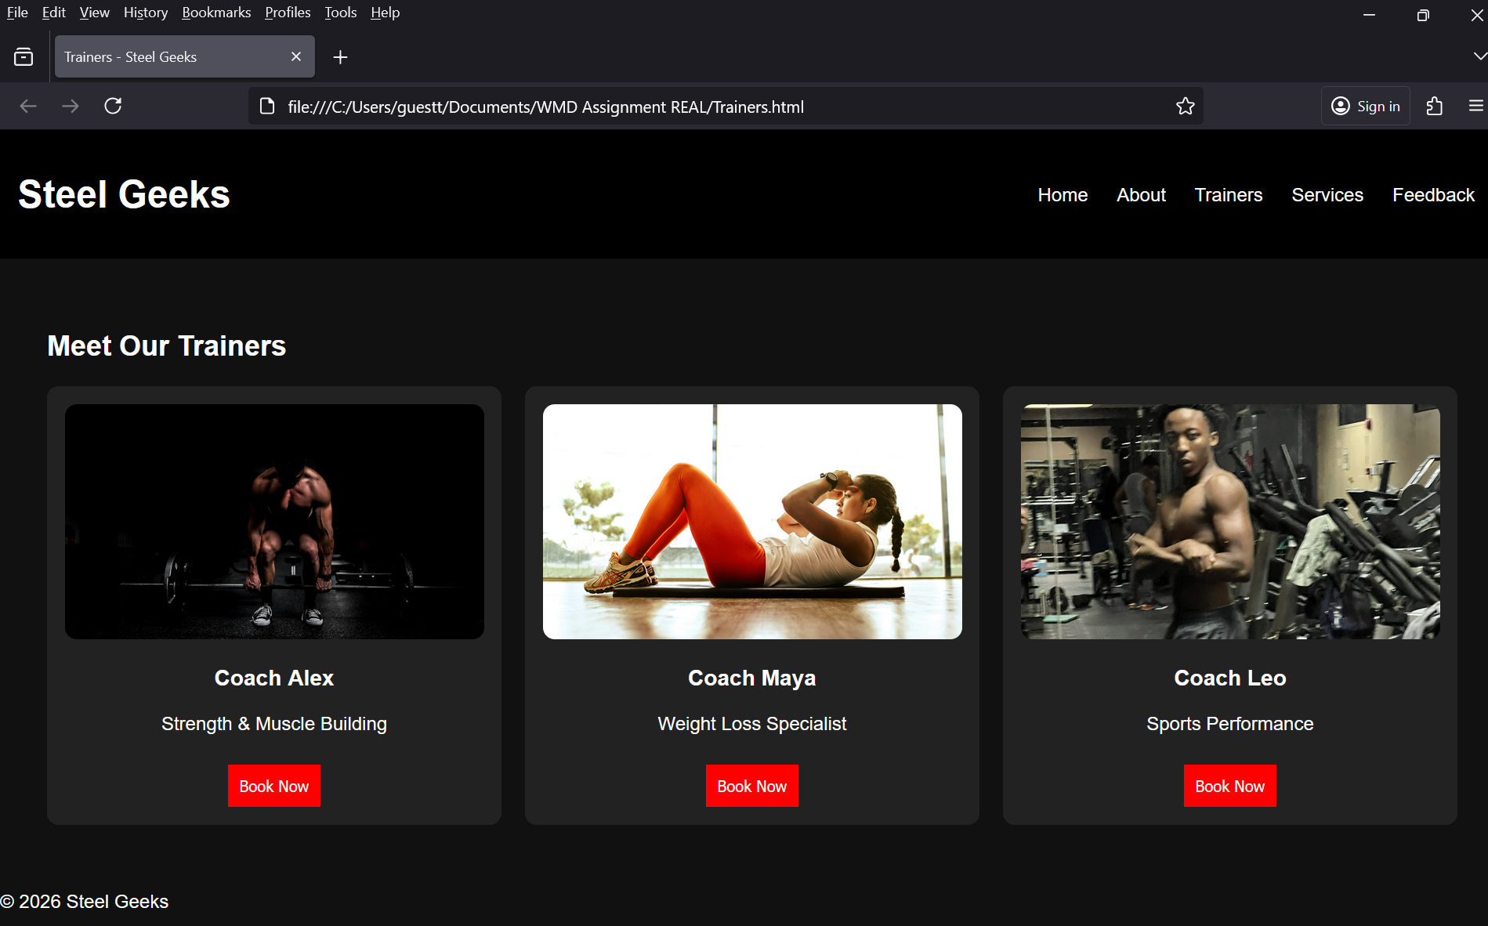

Mobile tests
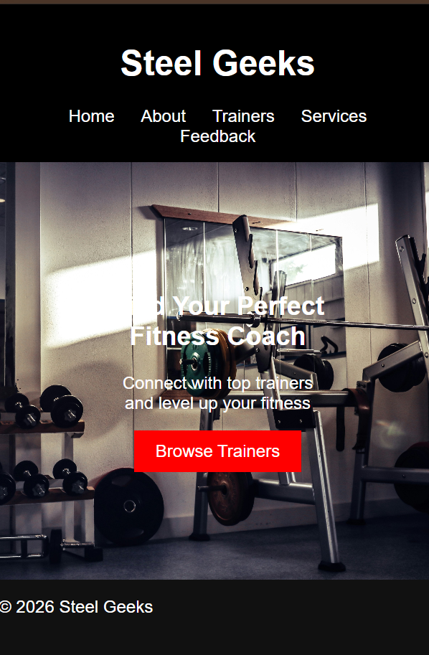
6. Publishing & Promotion (GitHub Pages Hosting)
To make the Fitness Geeks website available online, I used GitHub Pages.
How the website was hosted
First, I created a GitHub repository for the project and uploaded all the website files (HTML, CSS, images, etc.). After that, I enabled GitHub Pages in the repository settings so that the website could be published and accessed through a link.

Tools I used
- GitHub (to store and manage the project files)
- Git Bash / Command Prompt (to run Git commands)
- Visual Studio Code (to write and edit the code)
- Google Chrome (to test the website before and after uploading)
Git commands used
These are the main commands I used to upload the website:
git init
git add .
git commit -m "first upload of Fitness Geeks website"
git branch -M main
git remote add origin https://github.com/your-username/fitness-geeks.git
git push -u origin main
How it was published
After pushing the files to GitHub, I went into the repository settings and turned on GitHub Pages. I selected the main branch, and GitHub automatically built and hosted the website.
Website link
My website can be viewed here:
https://lamedikinya.github.io/FitnessGeeks/

7. Future Developments / Recommendations
There are still a few ways the Fitness Geeks website could be improved in the future to make it more useful, modern, and engaging for users.
One improvement would be to make the website more interactive, for example by adding a BMI calculator, workout planner, or a progress tracker where users can log their fitness journey.
Another upgrade would be to improve the design and responsiveness, so the website looks better on all devices, especially mobile phones. This could include smoother layouts, better spacing, and more modern styling using frameworks like Bootstrap.
Lastly, I would like to add more advanced features such as user accounts, so people can sign in, save their workout plans, and track their progress over time. Adding videos or embedded tutorials for exercises would also make the website more helpful and engaging.

